Artificial Neural Networks

Exercises report,

by,

Marimuthu Ananthavelu (MAI),

Student Number: 0652832,

KU Leuven.

Exercise-1 - Supervised learning and generalization

**1.1 Function approximation: comparison of various algorithms:**

The following Backpropagation algorithms are compared for performance with the given data.

1. ***trainlm*** is a network training function that updates weight and bias values per Levenberg-Marquardt optimisation.
2. ***traingd*** is a network training function that updates weight and bias values per gradient descent.
3. ***trainbfg*** is a network training function that updates weight and bias values per the BFGS quasi-Newton method.

The data are trained and tested using different feedforward network architecture with varying combinations of optimization techniques and the findings are as below;

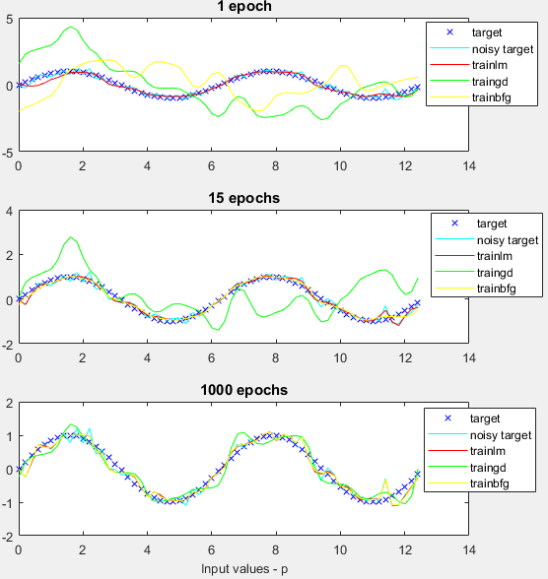

***Fig.2.Curve fitting for various algorithms with added noise***

***Fig.1.Curve fitting for various algorithms***

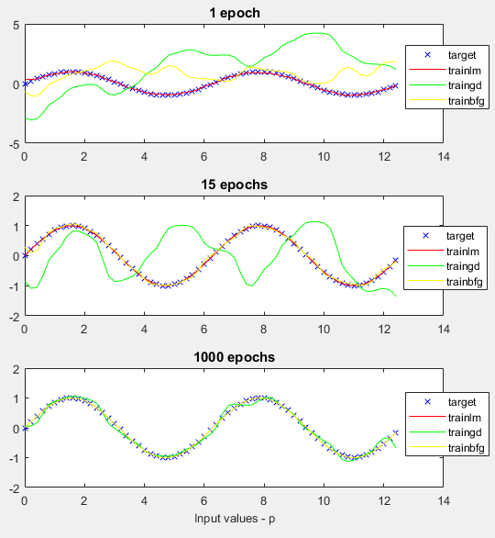

***Fig.1.Curve fitting for various algorithms without noise***



14 985

***Fig.4.Training time comparison***



***Fig.3.Performance measures comparison on training set***

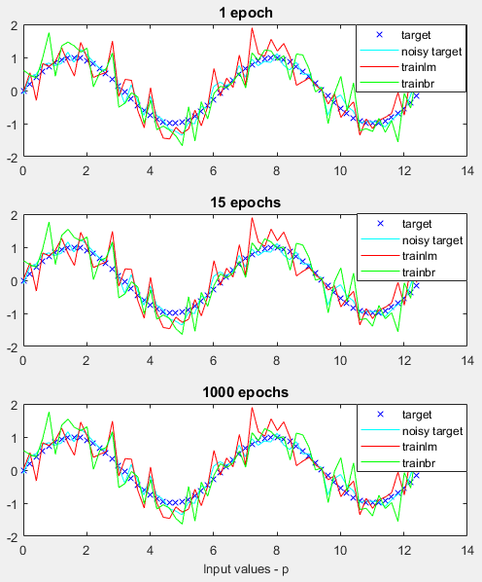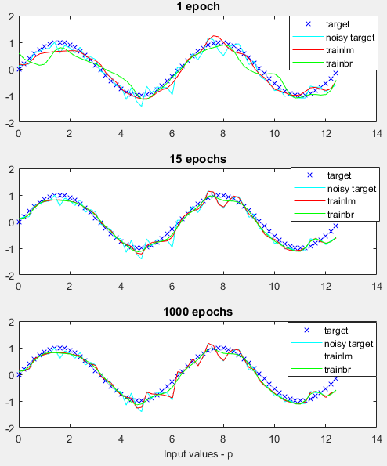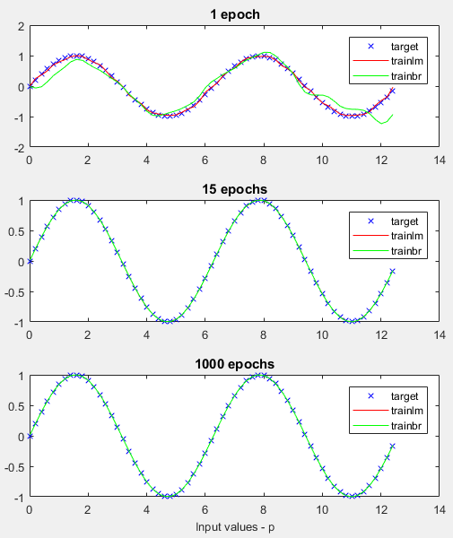

***Fig.5..Curve fitting for trainlm vs trainbr***

***(Neurons=20)***

***Fig.6.Curve fitting for trainlm vs trainbr with noise and overparameterization (Neurons=400)***

***Fig.6.Curve fitting for trainlm vs trainbr with***

***noise (Neurons =20)***

The above figures summarise the differences regard to the performance of the chosen algorithm, it’s training time, the changes in Mean Squared Error value with respect to different Epoch values.

***Discussion:***

Trainlm fits close with a minimum mean squared error with the target attributes for a given set of data. This is a case for all the three different Epoch values.

* With increased Epoch, all of the algorithms are performing better with a sharp decrease in the mean squared error except the gradient descent algorithm (‘traingd’).
* Training the network takes more time for ‘trainbfg’ algorithm in comparison to other algorithms with increased values of epoch.
* The performance measure Mean squared Error value for ‘trainlm’ algorithm is achieved minimum quickly with high accuracy for the whole range of given epoch values. Gradient descent algorithm ‘ perform less better than the other algorithms.
* After having added the noise data, the performance
* The performance of the algorithms are very similar to the one with no noise.
* Bayesian learning fits the target well where as the other learning algoritms fits the noise, though the convergence properties of the Bayesian looks very similar to the Levenberg-Marquardt optimisation technique as Bayesian uses the Levenberg-Marquardt as base algorithm.
* **Overparameterization**: Increasing the number of neurons does not have impact on the performance over the increase in the epochs converging to less number of epochs. LM overfits to the noisy training data which makes it generalizes poorly on test set. Though Bayesian approach did not improve with increase in the number of neurons, it performs better than LM because of its regularization leaving space for improvement.

Exercise-2 - Recurrent neural networks

***Hopfield neural network for Character recognition:***

Hopfield recurrent neural networks are the associative memories which works based upon the stored patterns i.e. given the partial information, the rest of the pattern is recalled. This work demonstrates the capability of Hopfield neural network to recall the original characters given the noisy character dataset. The network is given with the original characters set to learn from and later provided with noisy data with varying level. Hopfield network works based upon the analogy of having two neurons had been ‘on’ at a time, their synaptic connection is strengthened. The next time, some of them are activated, they will activate each other.

Hopfield networks come with energy function;

H $=-1/2\sum_{i,j}^{n}{Wi,j Si Sj}$ with $Wij=Wji$ and $Wii≠Wii$

which is either decreasing always or stay constant for convergence.

The activation dynamics is based upon the function;

$S+=sign(XjwijSj)$ where >0 indicates the attractor 1 and <0 provides -1.

The following figure shows the various combinations of Attractors (Original letters), noisy digits (after adding noise to the original letters), and the reconstructed noisy digits using Hopfield network.

***Noise level: 1% ; Number of iterations: 1***

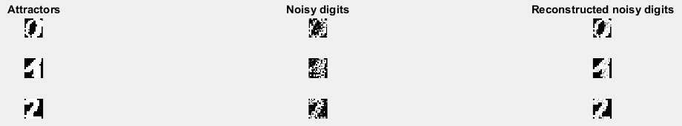

The reconstruction looks possible for all the digits with a very little noise and the network can be able to efficiently recall the original stored pattern.

***Noise level: 5% ; Number of iterations: 1***

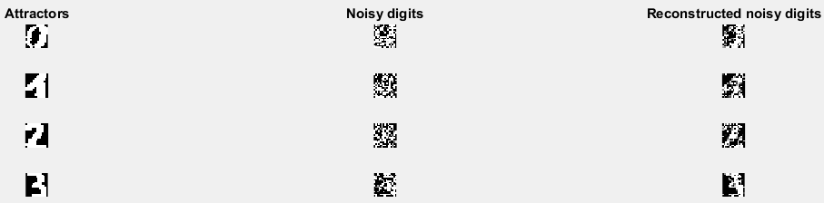

Looking at the reconstructed noisy digits, it looks like the Hopfield network finds it difficult to retrieve the Attractors with increased noise level and number of iterations, though they appear to be predicting.

***Noise level: 5% ; Number of iterations: 100***

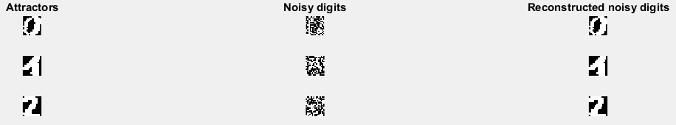

With increased number of iterations, the network can effectively recall the original letters with their memory levels. Thus, the accuracy of the Hopfield neural network comes at the expense of memory requirements which is a disadvantage to have.

***Elman Neural network:***

Elman recurrent neural network are the contextual units which is a two-layer neural network with ‘tansig’ neurons in hiddel layer and ‘purelin’ neurons in an output layer and a feedback from the hidden layer to the input. The feedback comes with delay of one step and Elman network can detect and generate time-varying patterns which makes it suitable for time-series predictions applications.

The Elman network architecture is as below;

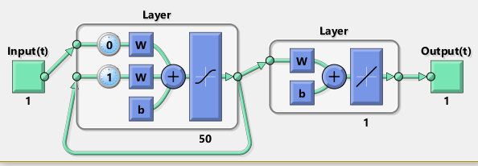

In this exercise, we use Elman network on the given Hammerstein system time series data. The results are as below;



Considering the performance of the network and the required memory complexity of the same, Elman recurrent neural network is less preferred for real time applications.

Exercise-3- Unsupervised learning -PCA and SOM

***Principal Components Analysis(PCA):***

Principal components analysis is the dimensionality reduction technique without reduction of the given input features. PCA is applied to the handwritten dataset of 3’s which are stored in the dataset ‘threes.mat’ and the findings are as below;

***Mean of dataset:***

The computed mean of dataset ‘threes’, Eigenvalues of the covariance matrix for the given dataset, the reconstructed image with 4 principal components are displayed as below;



When rebuilding the character set with the found principal components, there is reconstruction error which remains due to the fact the number of components is reduced. The more components we choose from the output vectors to rebuild the original character, the less reconstruction error it is to be. For the first 50 components, the reconstruction error appears as below;

For the first 50 components, the reconstruction error still appears. So, with all the output vectors from PCA (k=256), the reconstruction error ideally should be ‘0’. This can be checked by calculating/plotting the reconstruction error with k=256. The same can be seen below;

As seen above, the reconstruction error is decreasing with respect to the increase in the number of principal components which in turn makes the cumulative sum of the eigenvalues are reaching towards 1.

***Self-Organizing Maps:***

Self-organizing feature maps (SOFM) learn to classify input vectors per how they are grouped in the input space. They differ from competitive players in that neighbouring neurons in the self-organizing map learn to recognise neighbouring sections of the input space. Thus, self-organizing maps learn both the distribution (as do competitive layers) and topology of the input vectors they are trained on.

**Applying SOM on Cylinder data:**



***Fig. random topology***

***before training***

***Distance function: linkdist***

***Fig. random topology***

***after training***

***Distance function: linkdist***

***Fig.random topology***

***after training***

***Fig.random topology***

***before training***

**Applying SOM on Iris Dataset:**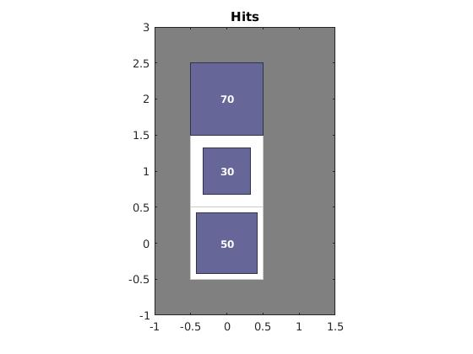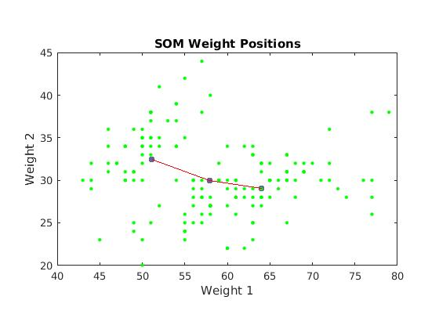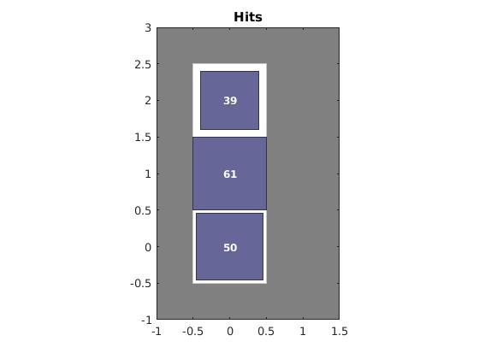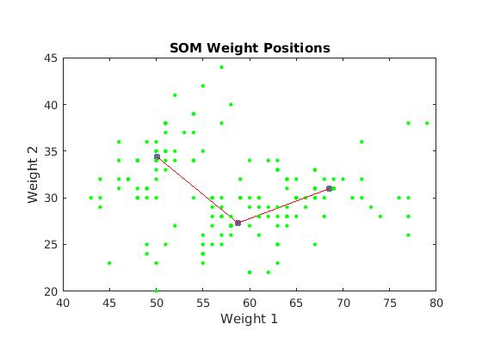

The Iris dataset has three classes of 50 data points each. In this exercise, a SOM with 3 neurons is fit to this dataset to see if a good clustering can be obtained using SOM.The Adjusted Rand Index (ARI) increases from 0.66 to 0.73 with increase of epochs from 100 to 1000. Fig.3.4 shows the neurons in weight space (1st two principal components). Also, the efficiency of clustering increases with increase in epochs. The neuron hits show how each neuron corresponds to each of the cluster. The hits get uniformly distributed with increase in epochs.

Exercise-4 -Deep learning -Stacked Autoencoders and Convolutional Neural Networks

***Stacked Autoencoders:***

Autoencoders are trained in an unsupervised, greedy, layer-wise fashion. It means No labels, beginning training with just the first layer of the network and then adding new layers on the move. The weights can be learned using a variety of techniques ranging from "batch" gradient descent to mini-batch stochastic gradient descent (SGD), to quasi-Newton methods like L-BFGS.In this work, the digits classification has been performed with the help of artificial dataset in which each digit is of 28 x 28 pixels images. The network architecture is as below;

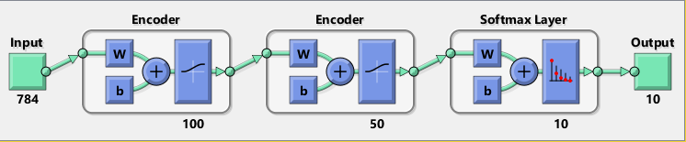

The idea is that the weights learned in an unsupervised manner to minimize reconstruction error for the representation learning task offer a good starting point to initialize a network for a supervised discriminative task such as classification or similarity. I.e., the network learns something about the underlying distribution by looking at the unlabeled data, allowing it to discriminate between labeled data. However, the weights still need to be "fine-tuned" for this new task. So ideally it is 2 step training process with Pre-training and Post-training.

***Convolutional Neural Networks:***

**First Convolutional Layer(layer-2)**

The weights obtained from these layers captures the basic image features, such as edges, dots, bright spots, dark spots and blobs. In our dataset, they represent edges of the airplane wings, ship floor windows, laptop mousepads etc. These "primitive" features are then processed by deeper network layers, which then combine the early features to form higher level image features better suited for classification. The filters on the first layer convolve around the input image and “activate” (or compute high values) when the specific feature it is looking for is in the input volume.

**Convolutional Layers -1 to 5 (layers 2 to 6)**

The dimension of the input at the start of layer 6 is a result of convolution at the earlier layers. Convolution and Pooling reduces the input sizes and not because of the ReLU or the Cross-Channel Normalization layer. Thus from figure 4.3, the dimension of input at layer 6 will be a vector of 4096 inputs features.

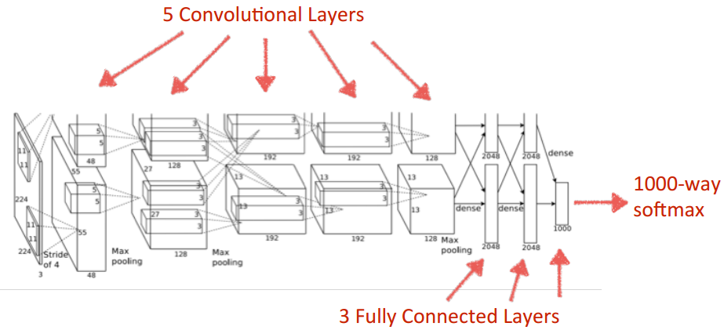

**4.2.3 Final dimension of the problem:**

For the Caltech101 dataset[1], the images of objects belong to 101 categories. The number of neurons (or features) at the final fully connected layer before the final SoftMax layer is 4096. The convolution net in this exercise process input images of size 227x227x3 = 154587 features. Thus, the final dimension used for classification is reduced by a factor of 15457/4096 ~ 38.

Exercise Session 5 – Final Project -Non-linear regression and classification with MLP’s

**Non-Linear Regression:**

The given noise free dataset contains the input features X1, X2 whereas the target feature is chosen based on the student number, r0652832 and the 5-different independent non-linear functions namely T1, T2, T3, T4, T5 mapping X1 and X2. The largest 5 different numbers of a student number are chosen to create the new target variable for the given dataset and used for regression analysis using the Multi-layer feedforward neural network.

Thus, Tnew = (d1T1 + d2T2 + d3T3 + d4T4 + d5T5) / (d1 + d2 + d3 + d4 + d5) whereas d1, d2, d3, d4 and d5 are 5 largest digits of student number in descending order which are 8, 6, 5, 3 and 2 respectively.

Which gives,

Tnew = (8T1 + 6T2 + 5T3 + 3T4 + 3T5) / 25

With the given total 13,600 data points, 3 independent samples (with replacement) of 1000 points each is drawn randomly with replacement. These are used as the training set, validation set and test set. As the three samples are all drawn independently, the assignment of these samples as training, validation or test set is arbitrary. After having split into these datasets. the surface of training set is plotted as below in Fig.5.1a.

****Surface plots:**



* **Number of hidden layers and number of neurons on each hidden layer:** The network is tried several hidden layers starting with one hidden layer as it can approximate any function that contains a continuous mapping from one finite space to another and it turns out that high accuracy is achieved using a single hidden layer. Alternatively, three different values for hidden units, valued at 10, 50 and 100, are tested and the best is determined using the validation set.
* **Learning algorithm:** Several learning algorithms are considered for this problem which includes, Conjugate gradient, Bayesian regularization and Levenberg-Marquardt. For this solution, the LM training algorithm is used. Considering the small dataset (1000 data points each) and since the data is noise free, gradient and Bayesian based algorithms are not considered. The chosen LM algorithm converges faster with good accuracy than steepest descent since for the given dataset, Hessian can easily be computed, inverted and stored in memory. For the same reasons, Quasi newton algorithm is not chosen.
* **Transfer function:**  ‘*purelin’* linear transfer function is used as the output activation function as this task is a regression. The nonlinear functions ‘*tansig’* and ‘*logsig’* are considered for hidden layer’s activation function and since the symmetric sigmoids such as hyperbolic tangent often lead to faster convergence than standard logistic function, ‘*tansig’* is used as hidden layer’s activation function.

**Task 3: Performance analysis:**

The performance of the selected architecture with parameters is evaluated on the test set. The best performance on the results are achieved for the architecture as shown below in Fig.5.2. It can also be seen from Fig.5.1c that the surface of the approximation given by the network closely resembles that of the test set (Fig.5.1b).

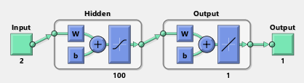***Model architecture:***

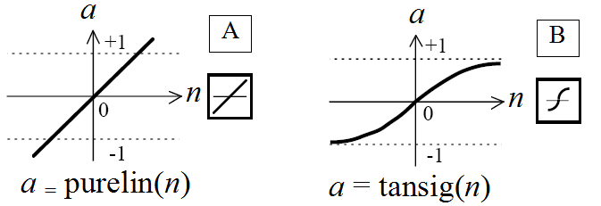



The Mean Squared Error on the validation and the test set are 1.0288e-05 and 2.4747e-07 respectively which are very close to zero. Fig.5.3 shows the decay of error. Also, the correlations between the actual test set and the test predictions are found to be perfect yielding R= 1(Fig.5.4). As the results are of high accuracy, no changes are made to the network for further improvements.

**5.1.2. Classification:**

This work demonstrates the binary classification task on the given wine dataset using Feedforward neural network. In addition, the application of dimensionally reduction technique, Principal Components Analysis(PCA) is performed and its effects on performance of classification are discussed. For this work, the student number is used for choosing the class types from the given wine dataset. For student number - r0652832), the positive class C+ is 5 and the negative class is 7 out of the 10 classes in the original dataset.

**Task 1:** **Design of Feedforward Neural Network:**

* **Number of hidden layers and number of neurons on each hidden layer:** One hidden layer with three different values for no. of hidden units, namely 10, 50 and 100, are tested and the best is determined using the validation set.
* **Learning algorithm:** The Levenberg-Marquardt training algorithm is used as it has could perform satisfactorily for the given dataset.
* **Transfer functions:** The standard logistic function *logsig* is used as the output activation function as the task is a binary classification. Hyperbolic tangent sigmoid *tansig* is used as the hidden layer’s activation function.
* The best results are achieved for the architecture as shown in Fig. 5.5. The Correct Classification Rate (CCR) on the test set is 86.29 %.

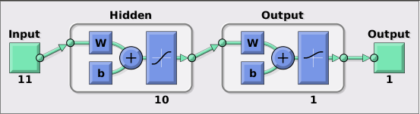

**Fig.5.5 Network architecture (10 hidden units) - without PCA**

**Task 2 and 3: Principal Components Analysis:**

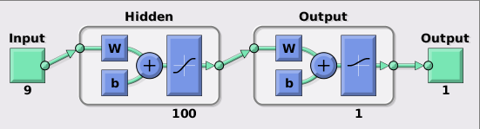 PCA is performed to reduce dimensionality. From the eigenvalue spectrum plot and the variance plot as shown in Fig.5.7a and Fig.5.7b respectively, the first two components already account nearly 99% of the variance. But instead of manually selecting the number of principal components, it is determined using the validation set. All other network parameters remain the same as the case with using the original dataset.

**Fig.5.6 Network architecture (100 hidden units) - with PCA**



**(a) Eigenvalue plot (b) Variance plot**

**Fig.5.7 PCA**

The best results are achieved at a CCR of 85.86 % which is close to that of working in the original dimensional space. Also, the optimal number of principal components was found to be 9 and not 2 although the first two accounted for a more than 99% variance. With just 2 principal components, the accuracy was found to be lesser. Thus, Principal Components Analysis reduced the dimension from 11 to 9 without affecting the accuracy with increase the hidden from 10 to 100 for the required performance.

The performance plots of two cases are plotted below.



1. **Without PCA (b) With PCA**

**Fig.5.8. Network Performance**

**5.1. Problem 2: Character Recognition with Hopfield Networks:**

The objective of this part of the project is to investigate the retrieval capabilities of Hopfield networks in the context of character recognition. The dataset is all the letter of the alphabet in capital characters, prepended with all the letters of my first and last name (marimuthu ananthavelu) in lowercase characters. Thus, the dataset contains 37 characters - 26 uppercase alphabets and 11 lowercase characters, namely m, a, r, i, u, t, h, n, v, v, l. These characters are reshaped to a vector of length 35 units which are then used as the input patterns that can be stored in a Hopfield network. The complete set of characters are shown in Fig.5.9

**Fig.5.9 Dataset**

**Task 1: Retrieving first 5 characters:**

As each character is of size 7X5, 35 neurons are used in the Hopfield Network. The first 5 characters m, a, r, i, and u are stored as patterns in the network. Then each character is distorted by 3 bits by inverting and tested with the network if it ends up in correct attractor pattern or not. From the results that are plotted in the following Fig.5.10, after 3 iterations, the five characters are perfectly retrieved whereas with a single iteration, the error is 11 pixels.

 

1. Original (b) Distorted (3 pixels) (c) Retrieved (1 iteration) (d) Retrieved (3 iteration)

Error: 11 pixels Error: 0

**Fig.5.10. Retrieving first 5 characters**

**Task 2: Critical storage capacity:**

The errors are plotted as a function of the number of patterns stored in our 35 node Hopfield Network. The number of patterns stored are increased from 1 character to total number of characters in the dataset, 37. For each incremental increase in character patterns, the distorted version is fed into the network and the recollected patterns are evaluated with respect to the original patterns in order. From the results shown in Fig.5.11, the error increases with the number of patterns stored as expected.

The theoretical critical storage capacity is computed from CTheory = N/(4*ln(N)) where N is 35, the number of hidden neurons. CTheory turns out to be ~2.46. Thus, maximum of 2 patterns can be stored in the network of 35 neurons. (marked by red *)

But from Fig.5.11, it can be seen that there is no error till the storage of 5 patterns. This could be due to the existence of spurious patterns. The network could have 3 spurious patterns or attractor states where some of the distorted versions of the characters converge.

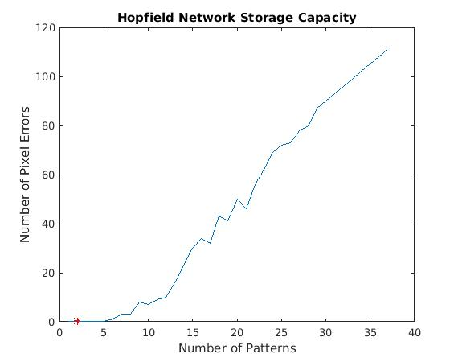

**Fig.5.11 Storage Capacity. Theoretical value is marked with red asterisk at 2.**

**Task 3: Storing 25 patterns:**

In this part of the task, 25 patterns have to stored in the network and the distorted versions of all the patterns have to retrieved perfectly. So in order to get a storage capacity of 25, the number of hidden neurons N has to satisfy the equation 25 = N/(4*ln(N)).

The original characters are in 7X5 pixel map format resulting in 7*5 = 35 hidden neurons. Now, N has to be chosen such that the pixel map is rescaled to same factor (y for instance) in both dimension to maintain the aspect ratio and the total number of neurons N = 7y*5y should yield a storage capacity of at least 25. The nearest integer satisfying the conditions is y = 5 giving N = 875. This gives a storage capacity of ~32 which satisfies the objective.

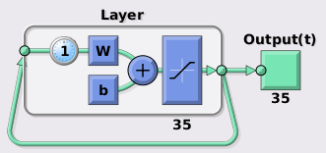 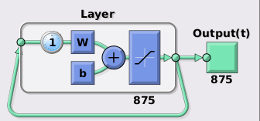

1. Original network (35 neurons) (b) Network for storing 25 patterns

**Fig.5.12 Network architecture**

Thus, to store and retrieve 25 patterns perfectly, a Hopfield network of 875 neurons is used which increases the complexity of the training. Also, each of the character pixel map must be rescaled from 7x5 to 35x25 to store them in the network. *Imresize* matlab routine is used and by default it uses bicubic interpolation method. To test the retrieving performance, the pixel maps in original format is first distorted by 3 pixels and then scaled to a factor of 5. Similarly, the output of the network is scaled down by ⅕ before comparing with the original pattern. The network recalls all the 25 patterns with an error of 2 pixels after 30 iterations. From Fig.5.13, the network has incorrectly retrieved the pattern ‘i’ as ‘l’ (which closely resembles each other in the way it is loaded) resulting in an error of 2 pixels.





**Fig.5.13 Output of network consisting 875 neurons**

1. http://www.vision.caltech.edu/Image_Datasets/Caltech101